We are all pleased to be back in school for the autumn term and, as part of our commitment to church and community, we have enjoyed taking part in different services at St James’, including a ‘New Beginnings Service’ (for the first time!), Family service and Harvest, and are looking forward to @open the Book’ visiting us in the next few weeks.

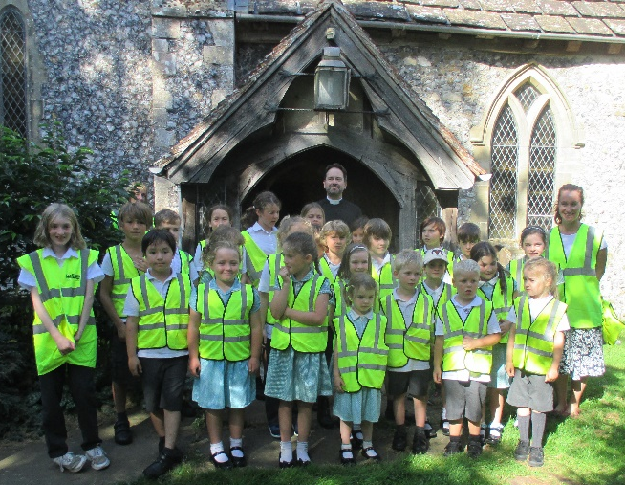
We had some mixed weather for our sponsored walks around our locality this year, but thoroughly enjoyed them none the less! We have elected our new Young Ashurst Governors this term and they sought the views of their peers before choosing which charities would benefit from our fundraising. They are delighted to announce that ‘The Brain Trauma Trust’, ‘The Wholesome Warehouse’ and the ‘RSPCA’ will each be receiving just over £231 - thank you to everyone who supported us with this.

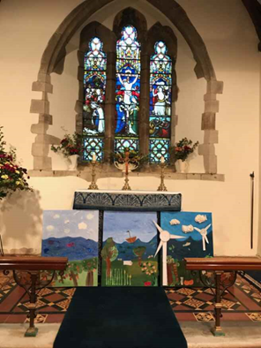
Our Christian value for this term is Respect and we have been thinking about how we respect God, each other, ourselves and our world. The children’s’ ideas about sustainable harvests are evident in their Harvest Art work, which we proudly displayed at Harvest Festival in St James’.

In our PSHE this half tern we are learning about celebrating differences - which is all about respect! We recently welcomed a drama expert during Black History month who worked with KS2 to broaden our understanding of people’s experiences of The Empire Windrush, whilst EYFS and KS1 explored traditional stories from Jamaica.

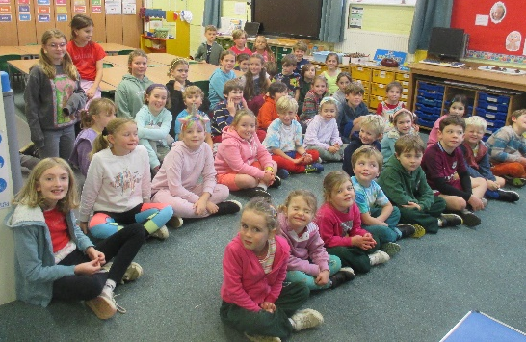
On our ‘Mental Health Awareness’ day, we all dressed in our favourite rainbow colours to celebrate our individuality and raise money for ‘Heads On’ – an NHS Foundation Trust which supports mental health.

As we write, we are very much looking forward to singing our new school hymn ‘Ring the Bell’ for the first time in public at the ‘Southdowns Concert Band’ concert on 13th November 6pm in St Andrews’ church in Steyning. We are also hoping that we can share it with you at family services at St James’ in the future.

Kindest regards
Mrs Smith and all at Ashurst CE Aided Primary School.

