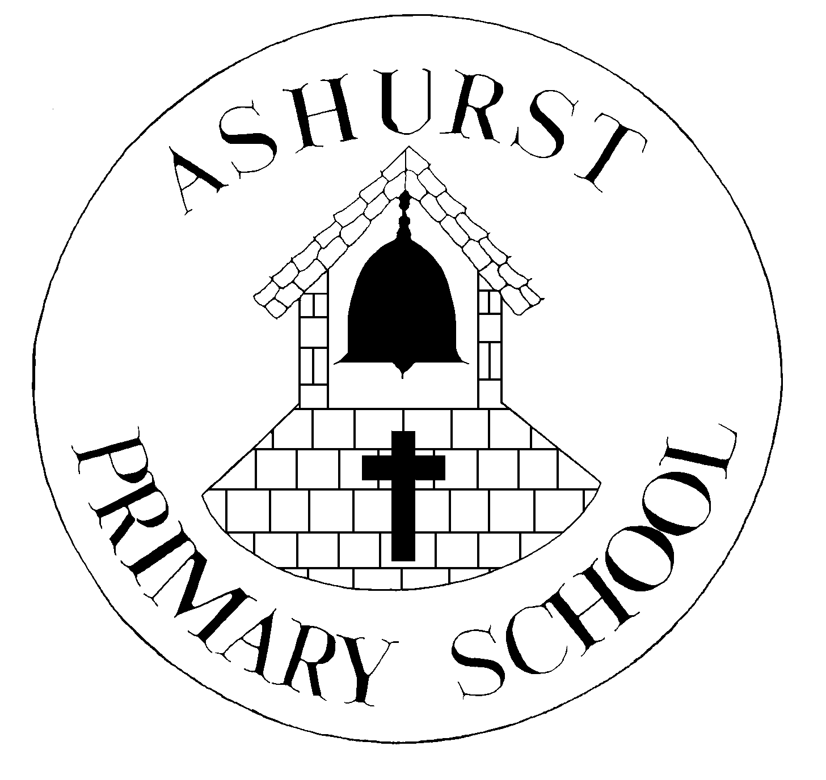 | WEST SUSSEX COUNTY COUNCIL  ASHURST CE AIDED PRIMARY SCHOOL  SCHOOL LANE, ASHURST, WEST SUSSEX  BN44 3AY  Headteacher: Mrs S Smith BA (Hons) RE & English PGCE | 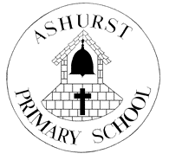
Email: office@ashurstcofe-pri.w-sussex.sch.uk www.ashurstcofe-pri.w-sussex.uk
Telephone: 01403 710426 Fax: 01403 710765

PARENT & CARER COVID-19 UPDATE 29th NOVEMBER 2021

Dear Parents/Carers,
We are writing to inform you that it has been reported to the school today that an infant pupil has been confirmed as having a positive COVID-19 result following PCR testing.
We know that you may find this concerning, but we are continuing to monitor the situation and are working closely with Public Health England. This letter is to inform you of the current situation and provide advice on how to support your child. Please be reassured that for most children, coronavirus (COVID-19) will be a mild illness.

Ashurst Primary School remains open and your child should continue to attend as normal if they remain well. All students and staff, regardless of year group, should remain vigilant regarding COVID-19. All parents are advised to continue with the routine twice weekly asymptomatic LFD COVID-19 testing of those in year 7 and above in the household.

If you think your child is a close contact but has not been contacted directly by NHS Test and Trace then they should take a PCR test via Get a free PCR test to check if you have coronavirus (COVID-19) - GOV.UK (www.gov.uk) or by calling 119. Further guidance can be found at Guidance for contacts of people with confirmed coronavirus (COVID-19) infection who do not live with the person - GOV.UK (www.gov.uk)

What to do if your child develops symptoms of coronavirus (COVID-19) or tests positive for COVID-19
The main symptoms of coronavirus (COVID-19) are a new, continuous cough, or a high temperature, or a loss of, or change in, their normal sense of taste or smell (anosmia). If your child develops symptoms of coronavirus (COVID-19), they should get a PCR test via Get a free PCR test to check if you have coronavirus (COVID-19) - GOV.UK (www.gov.uk) or by calling 119 and remain at home at least until the result is known. If negative, the child can end self-isolation; if positive, the child should isolate until at least 10 days after their symptoms appeared. They can return to their normal routine and stop self-isolating after 10 full days if their symptoms have gone, or if the only symptoms you have are a cough or anosmia, which can last for several weeks. If they still have a high temperature after 10 days or are otherwise unwell, stay at home and seek medical advice.

If the child has a positive test result but do not have symptoms, they should stay at home and self-isolate for 10 days from the date the positive test was taken. This isolation period will be extended if they go on to develop symptoms by counting 10 full days from the day following their symptom onset.

Instructions for people who live in the same household as someone with COVID-19 (tested positive or symptomatic awaiting a test result)

Please see the stay at home guidance with information of what the household should do and who is exempt from isolation as a close contact. Even if you are exempt it is recommended that contacts get a PCR test, and undertake other measures outlined in the guidance such as limiting contact with anyone who is extremely clinically vulnerable and wearing a face covering in enclosed spaces while the person in your household with COVID-19 is self-isolating.

If you / your child develop symptoms at any time, even if these are mild, self-isolate immediately, arrange to have a COVID-19 PCR test and follow the guidance for people with COVID-19 symptoms.

For most people, coronavirus (COVID-19) will be a mild illness.

If your child does develop symptoms, you can seek advice from the nhs.uk website at https://www.nhs.uk/conditions/coronavirus-covid-19/check-if-you-have-coronavirus-symptoms/. If you are concerned about your child’s symptoms, or they are worsening you can seek advice from NHS 111 at https://111.nhs.uk/ or by phoning 111.

Contacts who are not required to self-isolate from 16 August 2021

From 16 August, you will not be required to self-isolate if you are notified you have had close contact with someone with COVID-19 and any of the following apply:
- you are fully vaccinated
- you are below the age of 18 years 6 months
- you have taken part in or are currently part of an approved COVID-19 vaccine trial
- you are not able to get vaccinated for medical reasons

Fully vaccinated means that you have been vaccinated with an MHRA approved COVID-19 vaccine in the UK, and at least 14 days have passed since you received the recommended doses of that vaccine.

If you are a health or social care worker or student working in health and social care settings who has been identified as a household contact and are exempt from self-isolation, there is additional guidance available that you should follow to reduce the risk of spread of COVID-19 in these settings including not returning to work until you have a negative PCR test.

Students who are under the age of 18 years and 6 months or older students who are fully vaccinated can still attend the educational setting if identified as a close contact. They are recommended to get a PCR test* if 5 years and older (for household contacts there is no lower age restriction), avoid anyone who is extremely clinically vulnerable for the time they would have isolated and follow additional measures outlined below.

*They should not arrange to have a PCR test if they have previously received a positive PCR test result in the last 90 days, unless they develop any new symptoms of COVID-19. It is possible for PCR tests to remain positive for some time after COVID-19 infection.

How to stop coronavirus (COVID-19) spreading
There are things you can do to help reduce the risk of you and anyone you live with getting ill with coronavirus (COVID-19): guidance on how to stay safe and help prevent the spread

- get vaccinated – everyone aged 18 and over can book COVID-19 vaccination appointments now. Those aged 16 and 17 will be invited to book an appointment: Who can get the coronavirus (COVID-19) vaccine - NHS (www.nhs.uk). Those who are aged 12-15 who are themselves clinically extremely vulnerable or live with someone who is clinically extremely vulnerable or meet JCVI recommendations (JCVI statement) are also eligible.
- wash your hands with soap and water or use hand sanitiser regularly throughout the day
- cover your mouth and nose with a tissue or your sleeve (not your hands) when you cough or sneeze
- put used tissues in the bin immediately and wash your hands afterwards
- meet people outside and avoid crowded areas
- open doors and windows to let in fresh air if meeting people inside
- wear a face covering when it's hard to stay away from other people – particularly indoors or in crowded places
- participate in twice weekly LFD testing following national guidelines (recommended for 11 years and over). We encourage you to log your results here: https://www.gov.uk/log-test-site-covid19-results

Further Information
Further information is available at
https://www.nhs.uk/conditions/coronavirus-covid-19/
We are currently awaiting further advice from the DfE & Public Health England regarding the new reported variant of Covid and will update you should there be any changes.

Yours sincerely
Mrs S Smith Headteacher & Mrs A Hedley SLT

