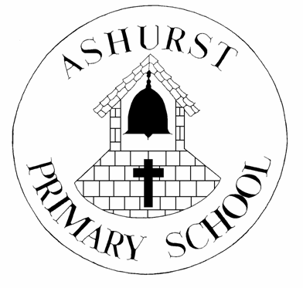
ASHURST CE PRIMARY SCHOOL
CURRICULUM TOPICS
SUMMER TERM 2018

KEY STAGE 1 & EYFS
The theme for the first half of the Summer Term is ‘Food, Glorious Food!’
Pupils will be learning about how food is grown. There will be visits to Bumbles’ Garden to participate in planting and growing food. The pupils will look at different food types and think about which ones are needed to maintain a healthy diet. They will produce observational drawings and artwork – focusing on the textures, shapes and patterns of different food.
For the second half of term pupils will be learning about the sea and life that inhabits the Oceans of the world – ‘Under the Sea and Over the Ocean’. This topic will enable pupils to think about how water offers different environments for animals that live in them. Stories and poems will be based around the topic and use these to create their own writing. Pupils will look at various creatures that swim in the sea and use different research methods to discover information about them.
Mrs Pockett
KEY STAGE 2
As part of our topic this term ‘The Wild Wilderness’, we will explore the concept of ’wild’ and ‘wilderness’ and ask ourselves: What is it like to live in the wilderness? Where are these places? and Were human beings once wild?
We will examine how conservationists strive to protect the beautiful wild lands that are under threat from hunters and developers, and reflect on the struggle to safeguard endangered wild animals.
We will be reviewing Spike Jonze’s 2009 film version of ‘Where the Wild Things Are’. We will also be reading several texts based in South and Central America which will help us to further explore the concept of wild and wilderness. Non-fiction work will include writing invitations, persuasive writing, letters and poetry around the subject of the Rainforest,
As Scientists we will be identifying and describing the functions of different parts of flowering plants and examining different techniques for seed dispersal. We will explore the essential elements required for plants to flourish; how these can vary from plant to plant, and how plants are suited to their environment. We will be studying how environments can change and the consequences of this for living things.
As Geographers we will be learning about South America and some of the countries within it. We will explore its key physical and human characteristics, including those of the rainforests. We will also be investigating the diversity of rainforest landscapes and climate. We will be comparing these to our own landscapes and climate in the UK.
As artists we will look at the work of some famous Southern and Central American artists and the mediums that they choose.
Mrs Smith
Y5 & Y6
Over the Summer Term Y5 & Y6 will be looking closely at the living creatures in our local environment. They will be learning about classification of living things, including micro-organisms. Pupils’ existing knowledge of ‘sorting’ animals will be extended through learning about the first Standard System of Classification, developed by Carl Linnaeus. A science investigation will be conducted, concerning the growth of mould on bread as well as an in-depth field study of the Ashurst Recreation Ground as part of the topic.
Y6 pupils will consider the differences between their local environment and that of Swanage, Dorset whilst on their Residential Field Study trip during the second half of term. They will develop their mapping skills, reading a range of maps as well as using an Ordnance Survey Map to plot specific routes.
In the latter part of term pupils will be looking at the work of a local landscape artist, as well as painting their own interpretations of our surroundings.
Ms Simpson

