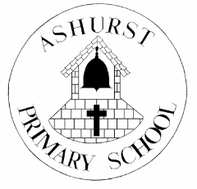
ASHURST CE AIDED PRIMARY SCHOOL

SUMMER TERM 2020

During this time of lockdown and school closures, our pupils have been doing all sorts of interesting and wonderful things. For one of our local families, here in the village, this has included birthday celebrations. One lovely present was the receipt of the book by Charlie Mackesy entitled, ‘The Boy, the Mole, the Fox and the Horse’. In response to reading it, one family member (Elsa, currently in Y4 at Ashurst CE Primary) wrote the following review and posted it to us.
Here it is, just as it was written. We hope you enjoy it and find it as beautiful as we did:
…………………………..It is a very heart warming story and tells you a lot about life. It gives you confidence and brings happyness to your life. It makes love feel like a big thing, but actually all you need is a friend. Once all these hard times are over we will come back loving each other more than ever. It assures you that ever in the hard times everything will be ok. Also it tells you “When the big things feel out of control ……. focus on what you love right under your nose.”……………………….
Best wishes from all at Ashurst CE Aided Primary School

