April 2022
Easter Foodbank Parcel
We look forward to welcoming you to our Foodbank or Mobile Foodbank, Hub-on-the Move, over the Easter holiday period. We will have Easter Eggs and Easter treats available, as well as our standard items, for you to choose for your family. Please bring this referral letter with you when you visit our Foodbank. A list of the locations and times is attached.

Connecting Café
You are also invited to join us at our new community Café, which runs once a week in St Andrews Church, Roffey. The Connecting Café – Eat, share, donate, is open Tuesdays from 11.30am until 1.30pm and provides drinks, cakes and a hot meal. This works on a ‘Pay if you can’ basis.
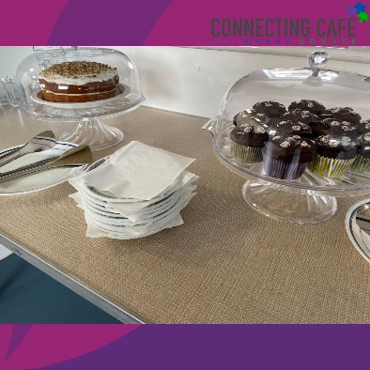
Budgeting Support
More than just a Foodbank – you can contact us for Budgeting support, Debt Advice and a Benefits Check on 0300 124 0204 or via support@horsham-matters.org.uk.
Toy Bank
We operate a Toy Bank all year round to help with your child’s birthday as well as at Christmas time. Please contact us with the name and date of birth of your child and we will arrange for you to select a gift.

To access any of the above services all year round, please call us on 0300 123 0204 or email us via support@horsham-matters.org.uk.

