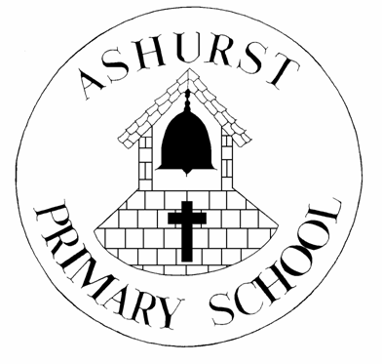
ASHURST CE AIDED PRIMARY SCHOOL
RETURN TO SCHOOL LETTER TO PARENTS
AUTUMN TERM 2021
RISK ASSESSMENT FOR ALL PUPILS
1st SEPTEMBER
The Safety of children and staff continues to be our utmost priority at Ashurst Primary School, together with providing an enjoyable and creative learning environment for all.
Ashurst CE Aided Primary School continues to follow Government guidance – Coronavirus (COVID-19); implementing protective measures in education and childcare settings; along with adhering to the latest guidelines and legislation concerning the prevention and management of sickness within the school setting, including throughout the current and ongoing Covid-19 situation.
Covid-19 Rapid Flow Testing is now available to all families from pharmacies and/or via the NHS website. All staff have available Rapid-Flow test kits for twice weekly testing and guidance continues to be followed throughout.
RISK FACTORS:
Risk Factors for Ashurst CE Aided Primary School remain - hygiene, hazard of infection, control measures including enhanced ventilation, wellbeing & welfare of pupils & staff - including mental health & wellbeing. The list is not exclusive and will continue to be updated and amended in response to changing circumstances.
MEASURES IN PLACE:
- SLT/s to be on duty at access points drop off and collection times
- Parents not to enter school site, pupils’ access only through entrance gate
- Hand wash on entry to school site – handwash station at Junior entrance.
- Hand wash stations in each group location, plus entrance doorways to school & office
- Enhanced ventilation where possible
- Tissues available in each group location
- Bins with lids in each group’s location for disposal of tissues
- DfE Signage throughout the school to remind all stakeholders of good hygiene methods e.g. handwashing & tissue use
- Internal doors to remain open where possible to reduce handle touch cross contamination
- Pupils to remain in class groups where possible
- Excess furniture removed to allow additional space where possible.
- Pupils to bring in their own water bottle each day
- Groups to have own sets of classroom equipment e.g. scissors/glue etc
- Behaviour rules & code of conduct focus lessons/discussions on entrance & reminders as appropriate
TOILET AREAS:
- Handwash soap and warm water available at all times
- DfE & schools own signage reminders for good handwashing hygiene & tissue use
PLAYTIMES/LUNCHTIMES:
- Allocated playtimes for groups/classes
- Handwash before and after play & frequently throughout the day as appropriate to activities
- Hard surfaces & equipment where appropriate to be cleaned whilst pupils at play/lunchtime by groups staff member
- Hot Schools Meals social distancing systems in place e.g. tables distance gaps/spacing queuing system small groups where possible
- Packed lunches social distance spacing and outside where possible.
- No food or drink cups/bottle sharing
CORRIDOR AREAS:
- Pupil access to other classrooms only where essential.
- Pupil access to office areas limited to when ‘essential’ only e.g. If pupil is unwell - when control measures will be actioned as appropriate to ‘illness’ or injury.
- Surfaces and door handles to be cleaned frequently and focussed cleaning where appropriate, including at the start and end of each day.
In addition to the identified points above there continues to be a specific focus on the wellbeing of all pupils, including their mental health; and regular and continued communication with those families not able to attend the school setting in line with current practise and procedures. This includes the implementation of Remote Learning under certain circumstances e.g where self-isolating due to Covid-19 restrictions.
There is continued provision for staff welfare and wellbeing from a range of outside agencies (contact details Staff Room) for individual and focussed support, together with regular meetings and opportunities to discuss ongoing changes and any concerns.
Guidelines for visitors and contractors will be clearly displayed, and conveyed to them, prior to admittance to the school building by a member of the Senior Leadership Team.
The school continues to have available a quantity of soap, hand gel, paper handtowels and anti-bacterial cleaning materials for the additional cleaning routines and heightened level of cleaning as scheduled.
This document will be updated and changed in response to a change of circumstances and/or as directed by PHE/DfE/NHS & West Sussex Local Authority guidelines.
Date: 1st September 2021
Signed:

Mrs S Smith Headteacher Mrs M Hedley SLT

