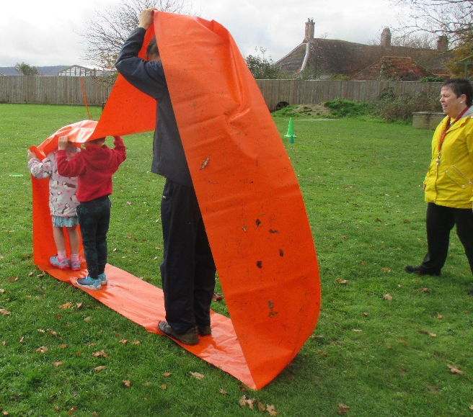
As part of our commitment to church and community, on Friday 13th November, the children of Ashurst Aided Primary School took part in ‘Children in Need’. This year there was an emphasis on being fit and well and Mr Ford (Horsham Leisure Link) supported each class in a variety of fun PE challenges on the field. Much laughter was heard as the children took part in activities such as tug of war and walking on the large caterpillar band. Our small school raised £68.71 This is addition to £652.26 raised earlier in the term through our Annual Sponsored Walks.
I worked with my friends. We had lots of fun and we were good at lots of things, like running and throwing the hoop. We did the caterpillar with Mr Ford.
Arthur

We did lots of different things on Children in Need Day. I liked the tug of war, the caterpillar, bowling and throwing Frisbees.
Zachariah

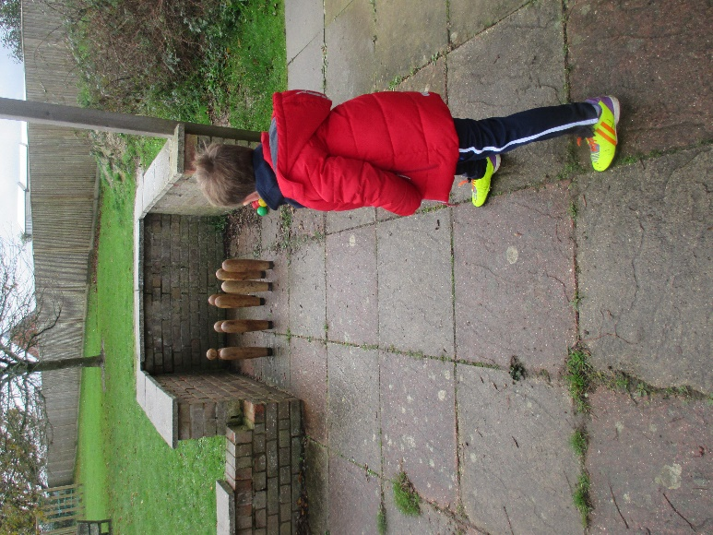

I liked using the ‘caterpillar’ band and the tug of war. I liked the tug of war when we fell over. We had to get back up and do it again.
Octavia
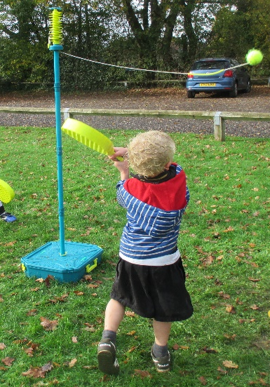


The children chose to support UK Mercy Ships, a faith-based charity that deploys hospital ships to some of the poorest countries in the world and SEVA, an organisation supporting marginalised communities in India by providing ‘radio boxes’ for essential health and educational information.
We are now looking forward to lots of exciting Christmas activities and
we wish you all a very MERRY CHRISTMAS, HAPPY & HEALTHY NEW YEAR.

